# Software Architecture Design

## Chosen Technologies

### Programming Language

Software architecture with regards to the programming languages will outline the justification to developers of why and how the chosen language will/should be implemented in the system.

We are making use of Python as our programming language in order to to implement the Django framework. Python is often viewed as a scripting language overlooking the fact that being as dynamic as it is, aids in rapid development. Python's standard library has more than 100 modules which coupled with Django makes it one of the most extensive rapid development packages.

Architectual advantages:

It is robust

Python has a relative small quantity of lines of code, which makes it less prone to issues, easier to debug, and more maintainable.

Flexible

Python is highly scalable becuase it wasn't originally created to answer a specific need, Python isn't driven by templates or specific APIs, and is therefore well-suited to rapid development of all kinds of applications.

Easy to learn and use

Since Python was not a language tought to us through the university, its ease of learning is definitly a aspect which is greatly valued

Databases technologies

When starting a Django project it present you with a settings file in which database specifications and configurations can be made in order to manage the the systems models will work.

It supports multiple databases - MySQL, PostgreSQL, Oracle & SQLite, MySQL being the chosen database we will incorporate into the system. The choice of MySql deeply aids in Flexibility by providing the capacity to handle deeply embedded applications with a footprint of only 1MB to running massive data warehouses holding terabytes of information. It's unique storage-engine architecture will aid in the concurrent querying that will take place.

Django's object relational mapper is an incredibly powerful database tool. It handles creation of your database, as well as insert, update, delete queries and some quite advanced querying.

This solves the architectual persistence constraint to a relational database

Testing in Django

Testing a Web application is a complex task, because a Web application is made of several layers of logic – from HTTP-level request handling, to form validation and processing, to template rendering. With Django’s test-execution framework and assorted utilities, you can simulate requests, insert test data, inspect your application’s output and generally verify your code is doing what it should be doing.

Application Servers

Support for both development and production servers has to be evident for operations in decoupling the various capabilities for the respective situations.

Django has a built in server which can be used for testing on one local machine. The buiilt in local development server is however not applicable in a production setting due to the fact that this server does not go through any form of security or performance tests its simply for local development before production development.

Django can be run in conjunction with Apache, NGINX using WSGI, or Cherokee using a Python module called flup. Django also includes the ability to launch a FastCGI server, enabling use behind any web server which supports FastCGI, such as Lighttpd or Hiawatha

## Chosen Framework

Software architecture framework provides the specification to developers how to organize and display the chosen libraries and design framework of a program. The framework provides a tool for the developers to use during the design of the software to include and implement the non-functional requirements as specified by the master specifications.

### Object/relational mappers

Object and relational mappers can be used by the developers to allow the integration and access of repositories without the continuous repetition of code. The mappers serve as a developer defined interface translator, that allows the integration of varies systems without violating the non-functional requirements of security. This technique can be implemented in the design of the program allowing the cross communication from the repositories to the object orientated design.

The use of new database with fields from the LDAP repository and CS MySQL database, as specified in the requirement documentation, will be used repetitively in all process interactions (4.1.2). Continues use of these repository lookups can be minimised with the use of ORM model. The integration technique allow the developer to minimise the coding used in the interaction points by separating the query lookup and the implementation of the lookup request. In the implementation of the mappers, the developer must ensure that the data crossover is in the correct format and type as multiple data structures can be accessed that differ from the original data input.

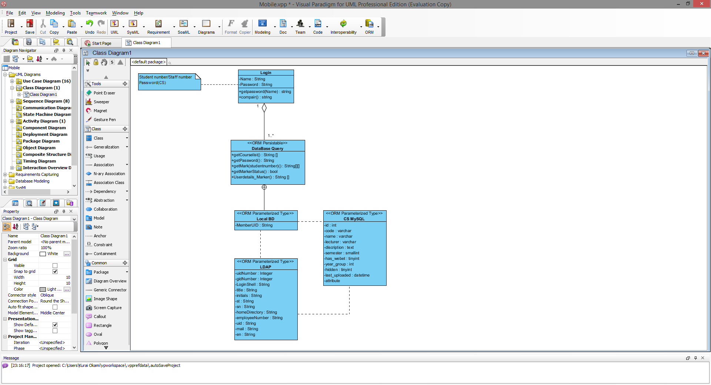

### Web frameworks

Web application framework allows the design and support of dynamic website and web services. As specified by the client, Django web framework will be used for the development of the web services. Django is an open source high level framework that implements the model-view-controller architecture pattern. The application is a Python based program that emphasizes the reusability of code and integration without the need of repetition. The framework implements an Object-relational mapper with a dynamic API for database access.

One of the most attractive aspects of Django is it's built in Admin capabilities, in other words creating seperate roles and capabilities for seperate users. This is a prerequisite for the system in order to provide differentiation between lectures and students and allow us to manage access capabilities for each stakeholder.

Django consists of a built in forms module which is the other greatly appreciated aspect of this framework. It provides extensive capabilities of validation based on various specifications, can even generate and update your database from a database model you create, make your job even easier.

### Web service frameworks

Web service framework allows the developer to decentralise inoperability and design front end services for web based applications. Frameworks allow the developer to improve on stability and design and allows connectivity on a word wide basis.

As per client request the web service framework must be an Apache based web service to be allowed to be run on an Apache web server. Apache CXF web service is an open source web service framework that allows the development of services using up frontend programming APIs. The web service allows the incorporation of a variety of protocols such as the SOAP, RESTful HTTP. This conforms to the constraints set by the client in regards to the protocols that must be used in the development of the program.